FIRST PRESBYTERIAN CHURCH
Connersville, Indiana
Moderator: Rev. Judith Fitchett

ANNUAL CONGREGATIONAL MEETING
February 5, 2017

THE AGENDA

- Moderator’s Call to Order and opening prayer
- Declaration of a Quorum
- Report of Nominating Committee and voting on new members
- Receipt of the Budget for 2017 / discussion
- Receipt of Annual Reports for 2016 / discussion
- Adjournment and Closing Prayer

INDEX

Page 1-2 Building & Grounds Committee Report

Page 3 Christian Education Report

Page 4 Clerk’s Report

Page 5 Deacons Annual Report

Page 6 Elder-Commissioner Report

Page 7 Fellowship Committee Report

Page 8 Mission Committee Report

Page 9 Nominating Committee Report

Page 10 Pastor’s Report

Page 11 Personnel Committee Report

Page 12 Stewardship Report

Page 13 Worship Committee Report

Page 14 2016 Year-End Financial Report

Page 15 2016-2017 Yearly Budget Comparison

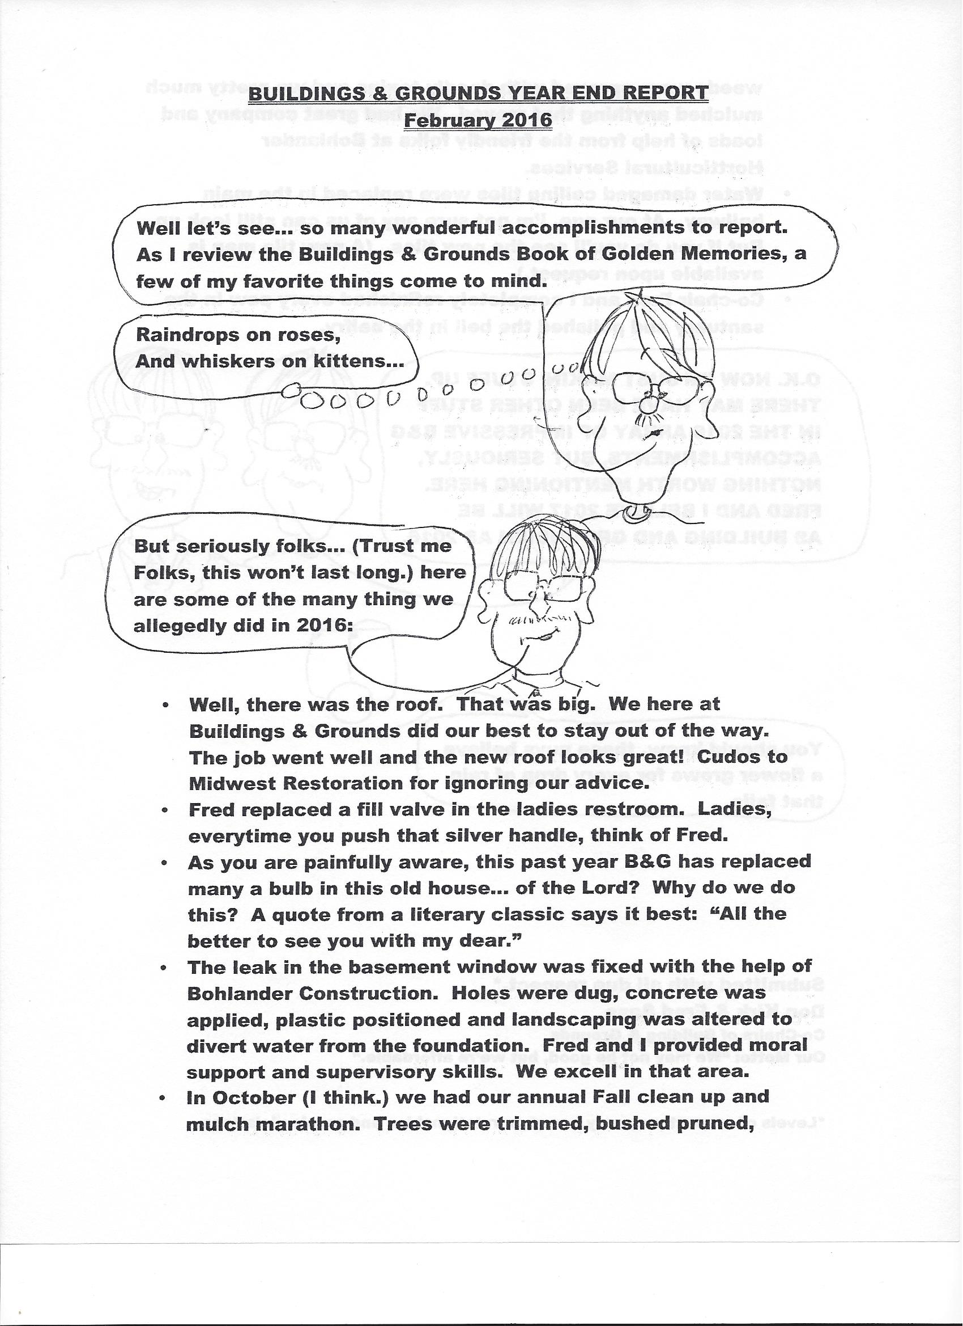

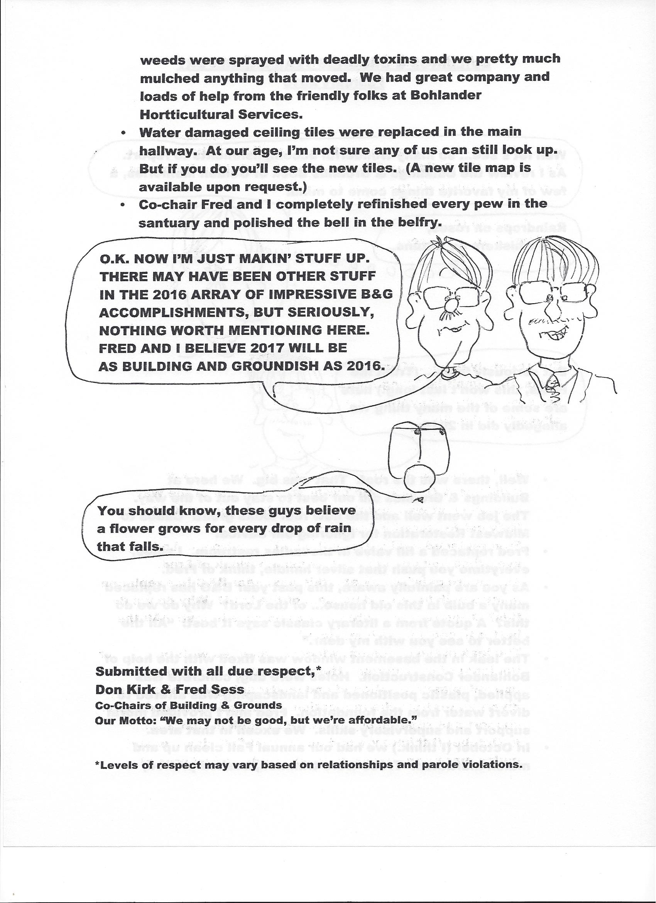

Christian Education Committee Report 2016

Cathy Kirk took over our Sunday School program and made sure we had lessons, crafts, supplies, and teachers every Sunday. Many thanks to Cathy and to everyone who contributed to helping children learn about their faith!  The Monday night Bible study group continued throughout the year. Pastor Judy encouraged an Easter art project in the spring, with chalk drawings on the back sidewalk.  In August the Bible study group produced hydrophobic art that was only visible when it was wet. These favorite scriptures were located on sidewalks all around the church and will disappear in a few months.  Respectfully submitted,  Carla Beard  Chair, Christian Education | x  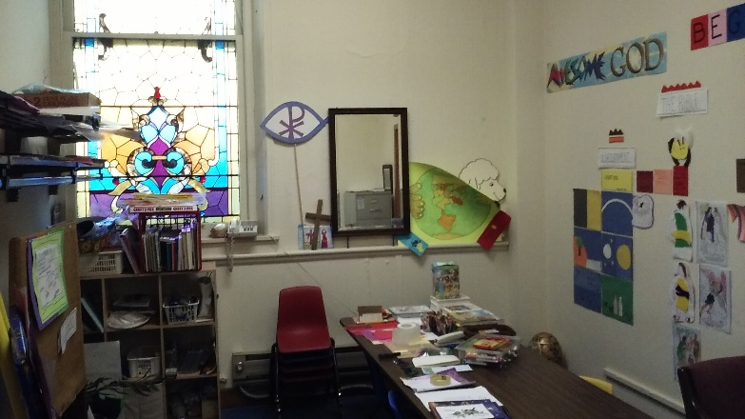  Sunday School Classroom
 | 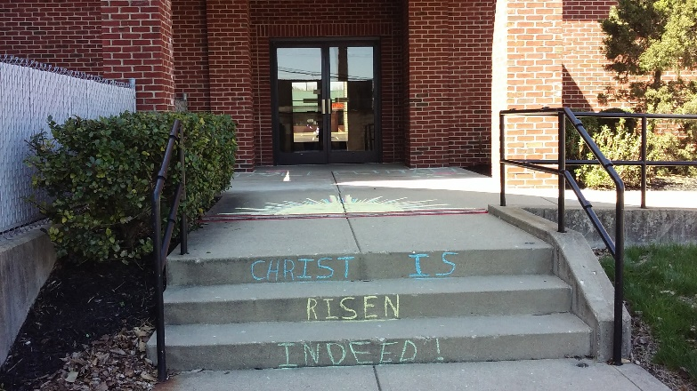
“Christ is Risen Indeed!”
Easter decoration

 | 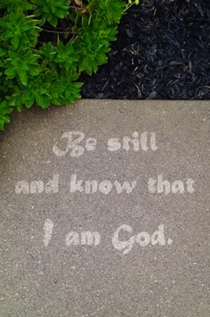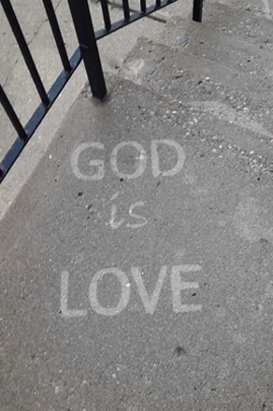
 | Encouragement for rainy days

Clerk’s Report

Attendance
Attendance for 2016 averaged 35.5 people per worship service. The 3 Sundays with best attendance were Christmas Eve, with 64; Easter, with 55; and Rally Day, with 54. The average attendance for the year was 35.5.
Membership
Gains
We welcomed 1 new member when Marilyn Maxwell was baptized and joined us.
Losses
We recorded the deaths of 3 active members, Esther Hassler, Betty Jobe, and Nancy Walker; and 1 inactive member, Betty Jo Schuler. We also said good-bye to members of our church family who transferred their membership to other churches or who were members in spirit.
We now have 71 active members.
Respectfully submitted,
Carla Beard
Clerk of Session

DEACONS’ ANNUAL REPORT 2016
Communion: prepared monthly by deacons as needed for Sunday, special events and home visits.

Cards: signed by deacons are sent to members of the congregation at special times like birthdays, anniversaries, congratulations, thinking of you, graduation and bereavements.

Flowers: flowers for each Sunday morning are monitored by deacons and purchased by church members in memory of, or in honor of family and friends. The Deacon of the Week is responsible for delivery of the bouquet. Poinsettias at Christmas are purchased by members and are taken home on Christmas Day. Extra plants are delivered to members who are unable to attend and are hospitalized or home-bound. The same procedure is used at Easter. Floral offerings remain $15.00.

Giving Tree: This project continues as an important need for children who have been taken out of their homes and placed with family, friends, or another child placement home, out of Fayette Co. Name tags are placed on a Christmas tree informing the giver sizes of clothing, shoes, and a wish list of special items. The giver buys and wraps gifts for a chosen child placing them in a large bag under our Giving Tree. Child Family Services picks them up and delivers them to the out of county home. This year 25 children were served.

Deacon Visitation: to shut-ins, and those who are hospitalized brings joy to both Deacons and the folks they visit. We are also able to serve communion during these visits.

Thanks to all Deacons for your service to this group, and to all other folks in our congregation who step in to help with each of the services listed above.

Respectfully Submitted,
Cathy Kirk

Fellowship Committee Report 2016
Our fellowship activities are more important than ever as we celebrate what makes us a church family.
Our February 7 Souper Bowl pitch-in raised $106 for the Community Sharing food pantry.
We celebrated our all-church birthday party May 22 with candles that went off like sparklers and played “Happy Birthday” (over and over and over).
We recognized the contributions of the choir and of our Sunday School teachers June 5.
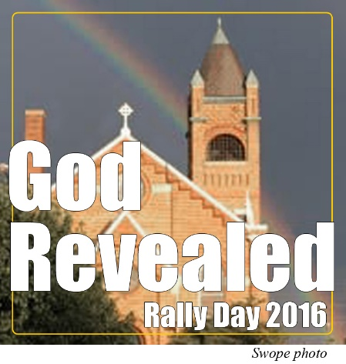
Rally Day was September 11. Pastor Judy chose a theme of “God Revealed.” In keeping with the Indiana Bicentennial, we also celebrated a Church Homecoming and were delighted to see old friends join us for the day. The Fellowship Hall was filled with food, friends, and laughter.

We celebrated Pastor Judy’s work with us during October, Pastor Appreciation Month. October also brought us an International Peace and Harmony celebration, a fun feast that helped us appreciate our blessings in the form of our heritage of food from all over the world.
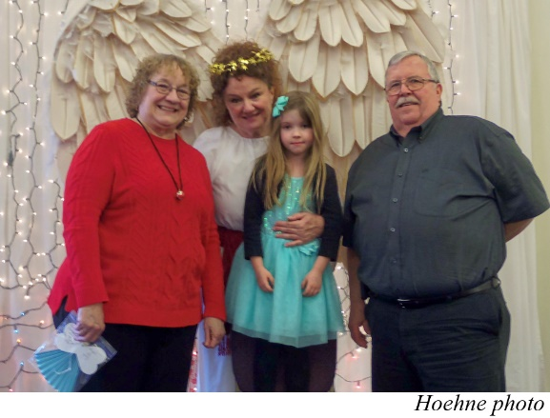
December 3rd brought the 12th annual Breakfast with the Christmas Angel. Susie Rogers and Kathie Matney, founders and longtime co-chairs, announced that they are stepping down. We appreciate their many years of enthusiasm and leadership.

In December Marilyn Stevens resigned after being our church secretary for 6 years. We recognized her with a gift and a gathering in the Fellowship Hall.
Many thanks to committee members Joyce Bohlander, Cathy Kirk, and Pastor Judy in setting up the calendar and in helping things run smoothly.

Respectfully submitted,
Carla Beard
Chair, Fellowship Committee
MISSION REPORT

There were five special offerings collected in 2016 for various Mission projects. These included the One Great Hour of Sharing, Christmas Joy, Pentecost, Peacemaking, and Souper Bowl Offerings.
A baby bottle for donations to the Hope Center was placed in the sanctuary as well.
We donated to the Haven, the hospital Chaplaincy program, the Presbyterian Disaster Relief (Gatlinburg fire relief), Hope Center, and Camp Pyoca.
The church collected food items for 27 Thanksgiving Baskets and 27 Christmas Baskets. Once again Family Video donated 20 hams and turkeys for these baskets. The committee purchased additional turkey breasts and smaller hams to go in the other 7 baskets at each distribution whose recipients are single or couples who did not need the large turkey/ham. Perishables of milk, eggs, butter, bread, and a dessert were bought from Kroger to be included in the baskets. This year we continued to add toilet paper, paper towels, dish soap, and hand soap to the baskets as well. We collected the items for the baskets throughout the year this year instead of just in the fall which seemed to work out well. Kroger donated a $100 gift card toward the perishables this year.
The Deacons once again sponsored the Giving Tree for providing Christmas gifts for 25 local children.
In the winter, our church helped assemble supplies and Vacation Bible School materials for Dorcas baskets for churches in the Southwest region of the Dominican Republic.
The church continues to collect non-perishable food items/paper products for the Community Sharing Foundation. This is an ongoing project for the church as collections are encouraged all year long.
In conjunction with other local churches and organizations, we are continuing to sponsor the Community Meals program on Sunday evenings. Our church serves meals on the first Sunday of each month.
A few members/friends of the church worked with the SAWS program to help build ramps for community members who need ramps installed at their homes for easier accessibility.
The Mission Committee would like to thank everyone who assisted with any of these projects this year.
Lisa Hazelrigg
Mission Committee Chairman

NOMINATING COMMITTEE ANNUAL REPORT FOR 2016
Cynthia Crispin, Chairperson
Members of the Nominating Committee for 2016 were chairperson Cindy Crispin, Larry Zumkeller, Sarah Smith, and ex officio member Pastor Judy Fitchett. (This slate was presented to and approved by the congregation at a meeting held February 7, 2016.)
New officers (Don Kirk and Mary Swope as Elders and Jill Yaryan as Deacon) were installed and Don Kirk was ordained during the church service on January 10, 2016. On January 21, 2016, Elder Robert Bryan tendered his resignation via e-mail to members of Session.
Members of the committee then met in February to discuss replacing Elder Bryan. Fred Sess agreed to fill out the remaining one year of Bryan’s term, and at a brief congregational meeting on February 28, 2016, Fred Sess was presented to and approved by the congregation. He was formally installed as Elder following the vote.
In September the Nominating Committee began its search for candidates to serve as officers for the upcoming years. Elder Beard provided a spreadsheet of current officers and their years of service. Elder Crispin forwarded the information to members of the committee.
Upcoming vacancies were as follows: Elders Lisa Hazelrigg, Fred Sess, and Cindy Crispin would be concluding three-year terms (with Fred Sess finishing out the final year of Robert Bryan’s term), and all would be eligible to serve again. Elder Carla Beard would be finishing six consecutive years as Elder and would be term-limited, leaving another vacancy. Deacons Ann Kirschner and John Bohlander would be finishing three-year terms, but both would be eligible to serve again. Deacon John Fairchild will have served six consecutive years and must be replaced.
A brief meeting was held after church in October with Sarah Smith, Cindy Crispin, and Pastor Judy in attendance. Potential candidates for officers were discussed, and each person, including Larry Zumkeller (who was unable to attend because of family emergency) was assigned an individual to contact. A congregational meeting was scheduled for November 20.
The Nominating Committee’s slate of officers was presented to the church members at the congregational meeting on November 20, 2016. There were no nominations from the floor, and the congregation voted to approve Larry Zumkeller (3-year term as Elder), Lisa Hazelrigg (3-year term as Elder), Fred Sess (3-year term as Elder), and Cindy Crispin (1-year term as Elder). Selected as Deacons were Kay Bishop (3-year term), Ann Kirschner (1-year term), and John Bohlander (1-year term).
The chairperson wishes to express her thanks to the committee members.

Respectfully submitted, Cynthia Crispin, chairperson
PASTOR’S ANNUAL REPORT

January 20, 2017
Annual Report for 2016

The 2016-year for First Presbyterian Church was a year of great sorrow and of great joy. It was a year that offered us more opportunities to know one another better – our good qualities and our challenges. It seems to me that our relationships seem more relaxed and a little more authentic. There have been many times when this church family has acted in faith and in love, in hope and in unity. It has been a year that has made me proud to be a part of the community of faith.

We did grieve some very real losses in our congregation in 2016. Mary Baker, Robert Bryan, Lois Fort and Will and Nan Rose left the Connersville area for reasons of family, work and health. We miss their presence and talents among us.

We shared a time of worship and resurrection with the family of Esther Hassler who passed away in May. In June, we celebrated the life of a dear friend and member of this congregation when 99-year-old Betty Jobe went to be with the Lord; we gathered with her family in the Fellowship Hall for a time of shared memoires and a shared meal after her service.

In August we shared a time of memorial with the family of Nancy Walker, who had been such blessing to this congregation. We also walked beside the family of Donald Maxwell in their grief, providing a time and space for them to gather and experience the love of this congregation and the hope we have in Jesus. This congregation rallied around Marilyn in the loss of her nephew, Charles Noll, in November.

We also opened our hearts and our building to our community and part of Nancy Harrell’s family as we celebrated Nancy’s life and witnessed to the promise of resurrection as a community of believers. Nancy struggled with “grit and grace” in the face of cancer and was a witness to how a Christian life of faith and love bears all things.

Late in 2016, Fred Sess lost his brother and Fred and his family have expressed deep appreciation for the support they have received from this congregation. We comfort one another in sorrow and we rejoice with one another in celebration.

With joy, we celebrated Wilma McLean’s 95th birthday with a visit and cards. Becky Morris’s mom, Martha Hunter also turned 95 and we helped to shower her with cards of Birthday wishes.

What a special day as we welcomed Marilyn Maxwell into our fellowship through baptism! It was a time of renewal for all of us as we remembered our own baptisms and celebrated with Marilyn and her family her commitment to Christ and to this congregation. Again, welcome, Marilyn.

We closed another year of Community Meals with participation by Peace Lutheran Church now filling the vacancy of Central Christian and several other organizations including Chartwells, who is the food service group for our schools here in Connersville. Several family groups, including the Nobbe family, have shared their Sunday evening with us and provided meals. Our group of providers is growing as well as the community served; we are feeding between 35-50 people on most Sunday evenings and are welcoming new faces and families. It is a blessing to many in our community that we can share this time together on Sunday evenings. It is well appreciated and by many and is a way of seeing God at work among us. Here we go into year # 3!

A Longest Night Service was offered on Dec. 21 along with our traditional Christmas Eve Candlelight Service on the 24th. Since Christmas fell on a Sunday this year we celebrated with a “Happy Birthday, Jesus!” party telling the story and celebrating with cake, ice cream and “goodie bags” during our worship time on Dec. 25th. As part of that worship, we were the recipients of two HAPPY BIRTHDAY, JESUS banners for Dr. Don Hauck – one for outside and one for inside. Thank-you, Don, we look forward to using those banners in the years to come!

As your Pastor, I have completed two long-term training programs in 2016. One was through the Presbytery/Synod for New Pastors. The other was offered and partially financed by the Presbytery in a course lead and directed by Stan Ott that focused on Leadership Training. I also attended the first step in Transitional Ministry training that is ongoing; this is a great training as we see so many churches experiencing transition, no matter how large or small.

In our community, I have been engaged with Rotary this year and also with the Fayette County Ministerial Assoc. where I am currently serving as Treasurer. I also have participated in the work of the Ministerial Association that includes being present at many governmental meetings to offer prayer. I have taken part in a couple of Connersville Visioning sessions and have talked with some folks from that group who are looking into food resourcing and the cooperation of churches of Connersville to enhance this endeavor. Art and I have participated with the Hope Center in programs that strengthen our community.

I firmly believe in the value of our Presbytery and applaud their efforts to become more supportive and act as resources to the churches and pastors they serve. We have benefited from these resources over the last year. Fred Sess has been a faithful commissioner from this congregation for several years and has served us well. Carla Beard accepted a committee position with Presbytery in 2016 and I have accepted a Committee On Ministry position for 2017.

Your Session and Deacon members have served well in 2016. They met for a combined Retreat in June of 2016 where we learned a little more about working as a team. We hope to continue those efforts in the coming year. As we move forward in 2017, my prayer is that we continue to work together in ways that honor God and transform lives.
We have broadened our education outreach to include a Monday evening Bible Study Class that ha been faithfully attended by between 7 and 9 women. Our studies have included books on prayer, as well as in-depth studies of scripture. We are currently using a guide prepared by N.T. Wright in our study of 2 Corinthians. These times of study an prayer together have opened us to many thoughtful and engaging discussions. God is at work as we gather together.

Please take time to read the reports of our Teams; Mission, Fellowship, Buildings and Grounds, Worship, Education, Personnel and Nominating. Thanks to all of you, those in leadership and those who continue to support through our congregation in so many way. Because of all of you there is much good work being done to share God within our faith community and within the community of Connersville.

We are in the process of developing our Finance and Stewardship Team; that will be ongoing in 2017. We give thanks to Larry Zumkeller who has faithfully served us as Treasurer, again, for all of 2016!

With the help and untiring support of so many, we continue to move forward into 2017. I pray that God will broaden our territory as we move into a new year. May our eyes, ears, hearts and minds be open to a new awakening of the Spirit moving in and through us. In a time of uncertainty, the church can be a stronghold. It is a good time to remind ourselves, our community and our world that our strength is in God – who is working with us, for us and in us. It is a good time to be the church!

In God’s Great Grace,
Pastor Judy

PERSONNEL COMMITTEE ANNUAL REPORT for 2016
Cynthia Crispin and Carla Beard, Co-Chairpersons
The Personnel Committee for 2016 included Larry Zumkeller and co-chairpersons Carla Beard and Cindy Crispin.
Elders Beard and Crispin met with Pastor Judy on February 16, 2016, to draft an updated protocol to address sexual harassment/abuse in the church environment. This sexual misconduct protocol, entitled Safe Boundaries Policy, was presented to Session on February 17 for approval and then was submitted to Presbytery in March.
Also on February 16, 2016, Elders Beard and Crispin met with Marilyn Stevens to do a performance evaluation. Various schedule modifications for church secretary Marilyn Smith were approved upon request throughout the first part of the year to accommodate her personal or family needs. In May, however, Marilyn tendered her resignation as church secretary but later agreed to take a family leave instead ranging from three to twelve months. Karen Dixon stepped in as interim secretary.
Elder Beard and Elder Crispin accompanied Pastor Judy to a pension board training held in Greenfield, Indiana, on August 25, 2016. Then on September 6, 2016, the personnel committee met at the church with Pastor Judy to discuss potential changes in anticipation of preparing the employer agreement due September 30. After consideration and discussion among the elders, and with the concurrence of Pastor Judy, the following changes will be recommended for her 2017 terms of call:
1) Art will be added to the health plan (which, incidentally, is a Presbytery-wide change to have all pastors on the family plan); 2) Pastor Judy will have a flexible spending account which is funded solely by her; 3) Pastor Judy will receive a $5000 increase divided as follows: a raise in salary of $278; a contribution of $2000 to a health savings account; and a contribution of $2722 to a 403(b) retirement account.
Larry Zumkeller took care of inputing electronically Pastor Judy’s selections for 2017 and submitted those selections to the Board of Pensions in advance of the September deadline. The members of the committee met at length on November 30 to finalize 2017 Terms of Call. The committee formalized a proposal which was presented by Elder Beard to the congregation at the December 11, 2016, congregational meeting. The proposed terms of call were approved.
Marilyn Stevens decided in November not to return to employment as our church secretary. The personnel committee addressed the old and outdated work agreement for the position and identified areas that needed updating or modification to suit current conditions. Karen Dixon was offered the secretary’s position on a permanent basis, and she accepted.
The Committee Chairpersons wish to thank the members of the committee for their contributions throughout this past year.
Respectfully submitted, Cynthia Crispin, Co-Chairperson
Worship Committee Annual Report 2016

The year 2016 has brought our congregation many blessings. We have worshiped under the guidance of Pastor Judy Fitchett as our called pastor. Elder Robert Swope, who has served as music director for forty-six years continues as choir director and organist. We are enjoying the music Bob brings us from our beautiful pipe organ and grand piano and our choir continues to bless us with special music from September thru May.

We are using the new Presbyterian Hymnal: Glory to God, and learning some new hymns and finding blessing in the old. Pastor Judy felt strongly that the new hymnal would enrich our worship. The new hymnals have been donated by members of the congregation and given in honor or in memory of others.

Pastor Judy enriched our Advent season with the addition of a special Longest Night Worship to strengthen those who have suffered a loss during the year. This reminded us that darkness may cover us, but God will bring new light to us in time. On Christmas Eve we gathered for worship with candles, communion and beautiful music then on Christmas morning we celebrated with a Happy Birthday, Jesus party complete with cake and decorations.

A special “Thank YOU!” to so many who helped make our worship meaningful and complete. We include all those who served as Liturgist, Choir member, Instrumentalist, Usher, Counter, Communion Server, Reader, Deacon or Elder. There are those who helped decorate the sanctuary for Easter and Christmas, provided altar flowers for worship and all the little behind the scenes jobs that just get taken care of without fanfare. A special Thank You to Carla Beard, and Richard Baker who filled the pulpit this year when the pastor was away. How blessed we are to have so many willing to step in and share their time, talent and Christian faith with us.

Finally, we want to thank you - the congregation - for it is all of you who make our worship services a time of prayer, joy, fellowship and blessing. To quote the old hymn “We Are the Church Together”.

Worship Committee,
Linda Ward
Jill Yaryan
Bob Swope
Mary L. Swope

PLEDGES

Pledges 2016 vs. 2017

2016 pledges $73,650.00/ 27 pledging units.
We actually received in pledged offerings a total of $79, 202.00; thus our pledgers responded with 108% of their pledged amounts.
Unpledged general offerings amounted to $11,524.05
……..
2017 pledges $62,770.00/ 25 pledging units
Our pledged income remains steady and may increase just a little per unit as our last pledges are counted. (We know of at least one more pledge yet to be received.)
We are so very grateful to our Treasurer, Larry Zumkeller, for another year of faithful and knowledgeable service. We are looking for a few folks to serve as a Financial Team along with Larry in the coming year; we need your help!

Pastor Judy

[Note: financial reports have been redacted by congregational vote.]

